A* ALGORITHM

**A\*** is an informed search algorithm, meaning that it is formulated in terms of weighted graphs: starting from a specific starting node of a graph, it aims to find a path to the given goal node having the smallest cost (least distance travelled, shortest time, etc.). It does this by maintaining a tree of paths originating at the start node and extending those paths one edge at a time until its termination criterion is satisfied.



D* ALGORITHM

**D ∗ algorithm** is a well-known graph search algorithm capable of fast re-planning in changing environments.

It is also known as a dynamic version of the Dijkstra's algorithm or dynamic version of the A∗ algorithm without the heuristic function

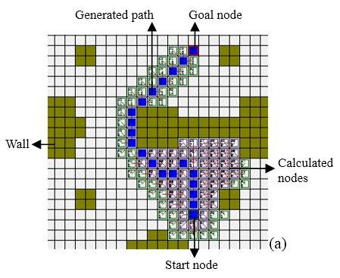

**DIJKSTRA'S** ALGORITHM

**Dijkstra's Algorithm** finds the shortest path between a given node (which is called the "source node") and all other nodes in a graph. This algorithm uses the weights of the edges to find the path that minimizes the total distance (weight) between the source node and all other nodes.



DFS vs. BFS

